Assignment Problem / Challenge
The assignment requires a campus or enterprise network in which several application classes coexist and impose different demands on the communication system. The network must contain at least four interconnected segments and at least 40 end devices. Four structural alternatives must be considered—star, mesh, bus and hybrid—and the selected design must be evaluated under changing network conditions.
This report treats the campus as four logical service domains: Administration, Academic Laboratories, Library/Services, and Hostel/IoT. Each domain contains ten logical end devices, resulting in a 40-device final design. TCP, UDP, HTTP and DNS are used as representative traffic classes because their transport behavior and application timing requirements are different.

Problem Statement
The engineering challenge is to provide dependable communication while traffic intensity, delay and loss change. A topology should not be selected solely because it is easy to draw; it should be evaluated using measurable indicators such as response time, useful throughput, packet loss, jitter, link utilization and successful delivery.

Objectives
The objectives are to design the four alternatives, specify suitable devices and media, create a four-segment addressing structure, formulate a repeatable traffic model, compute the required performance indicators, identify bottlenecks, compare the alternatives and justify a final topology using an explicit engineering decision matrix.

Design Requirements and Constraints
Requirement | Target
Segments | 4 interconnected segments
End devices | 40 minimum; 10 per segment
Topologies | Star, Mesh, Bus, Hybrid
Traffic | TCP, UDP, HTTP, DNS
Conditions | Low traffic, High traffic, Increased delay, Packet loss
Metrics | Latency, throughput, packet loss, jitter, utilization, delivery rate
Access medium | Cat6/Cat6A UTP Ethernet
Backbone | Gigabit Ethernet and fiber option for long/high-capacity paths
Addressing | Separate /24 subnet for each segment
Routing | Layer-3 inter-segment routing
Evaluation method | Common traffic model, common observation interval, repeated trials

Segment and Addressing Plan
Segment | VLAN | Network | Gateway | Endpoint set
Administration | 10 | 192.168.10.0/24 | 192.168.10.1 | PC-01 – PC-10
Academic | 20 | 192.168.20.0/24 | 192.168.20.1 | PC-11 – PC-20
Library/Services | 30 | 192.168.30.0/24 | 192.168.30.1 | PC-21 – PC-30
Hostel/IoT | 40 | 192.168.40.0/24 | 192.168.40.1 | PC/IoT-31 – PC/IoT-40

Technical Architecture
A hierarchical network is used as the base architecture. Endpoint traffic enters through access switching, crosses the aggregation/core function and reaches another segment or an application service. Logical separation is maintained with VLANs so that broadcast domains and traffic sources can be reasoned about independently.
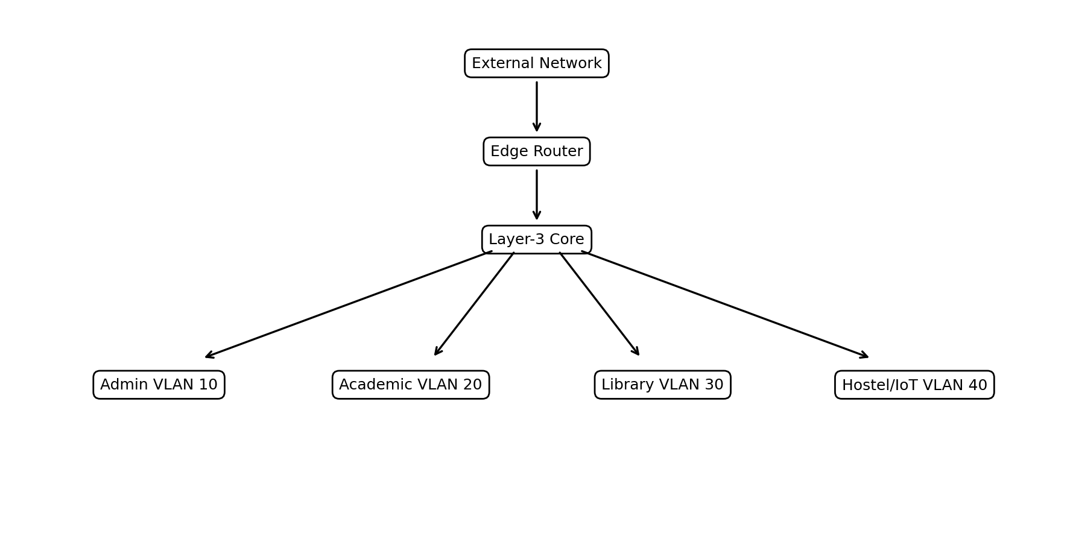
Figure 1. Four-segment technical architecture.
The architecture separates the access problem from the backbone problem. This is important because congestion normally becomes significant when multiple endpoint flows converge onto shared aggregation paths. The design therefore gives the highest design attention to the core and inter-segment links rather than treating every endpoint connection as equally critical.

Transmission Media, Devices and Standards
Component | Recommended selection | Technical justification
Endpoint cabling | Cat6/Cat6A UTP | Supports structured Ethernet access with low installation complexity and adequate bandwidth for ordinary endpoint traffic.
Access switches | Managed Ethernet switches | Provide separate access ports and permit VLAN-based segmentation.
Layer-3 core | High-capacity Layer-3 switch | Terminates VLAN gateways and performs inter-segment routing near the traffic aggregation point.
Edge device | Router/firewall boundary | Separates campus traffic from an external/WAN domain.
Backbone | Gigabit Ethernet; fiber where distance/capacity demands | Higher aggregate capacity and improved suitability for inter-building links.
Servers | DNS + HTTP/application services | Provide controlled destinations for the experimental workload.

Cabling Engineering Considerations
Copper access links are appropriate for ordinary horizontal cabling because they are inexpensive, easy to terminate and suitable for switched Ethernet. Backbone selection should be based on aggregate offered load rather than the bandwidth requirement of one PC. Fiber becomes attractive when buildings are separated by long distances or when electromagnetic isolation and higher bandwidth are required.

Segmentation Rationale
VLANs reduce the size of a broadcast domain and create a clean boundary for traffic accounting. They also make the experiment more repeatable because each application group can be mapped to a known source segment.

Star Topology Analysis
In a star topology, endpoint or access nodes converge on a central switching point. This makes the structure straightforward to expand and troubleshoot. A cable failure at one endpoint normally affects that endpoint only. The central node, however, becomes a concentration point for traffic and a potential single point of failure.
Criterion | Star assessment
Normal performance | High
Fault tolerance | Moderate
Scalability | High
Cost | Low to medium
Operational complexity | Low
Main risk | Central switching/aggregation dependency
From an engineering perspective, star is a strong baseline because its path structure is simple. Its weakness becomes visible when a large number of sources share the same central uplink. The uplink should therefore be designed with sufficient capacity and, where required, redundancy.
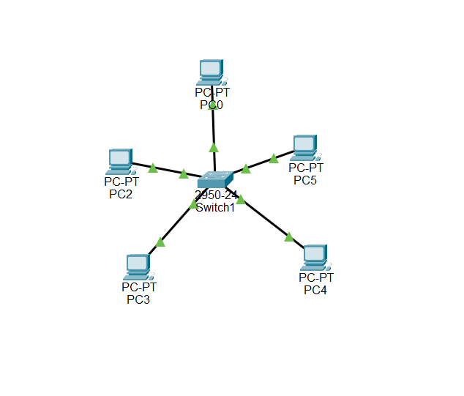

Mesh Topology Analysis
Mesh topology provides multiple infrastructure paths between major nodes. For a campus, a practical mesh is usually partial rather than a full endpoint mesh. The distribution or core nodes are interconnected so that traffic can take an alternate path when a primary path fails or becomes constrained.
Criterion | Mesh assessment
Normal performance | Very high
Fault tolerance | Very high
Scalability | Medium
Cost | High
Operational complexity | High
Main risk | Port, cabling and routing complexity
The mesh alternative is valuable as the resilience reference. It demonstrates how additional physical paths can preserve connectivity, but the extra infrastructure has to be justified by the criticality of the traffic or the cost of downtime.
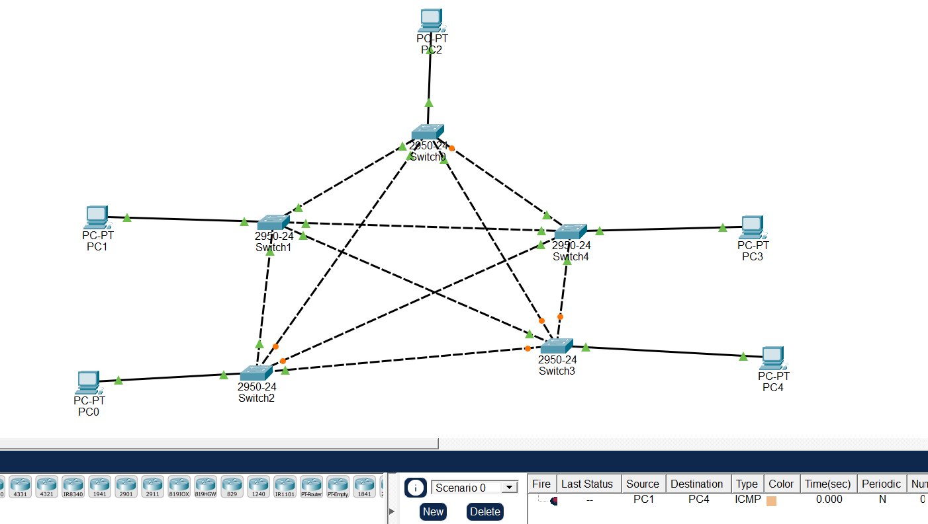

Bus Topology Analysis
A bus topology uses a shared communication path. As the number of simultaneous senders grows, more traffic competes for the same shared medium. The resulting contention and queueing make the topology useful as a stress-case comparator, although it is not normally preferred for a modern campus LAN.
Criterion | Bus assessment
Normal performance | Low to medium
Fault tolerance | Low
Scalability | Low
Cost | Low initially
Operational complexity | High at larger scale
Main risk | Shared backbone saturation
The bus model is technically useful because it demonstrates an important design principle: high utilization does not necessarily mean efficient operation. Once the shared path becomes congested, latency, jitter and loss can rise rapidly even if the network continues to carry traffic.
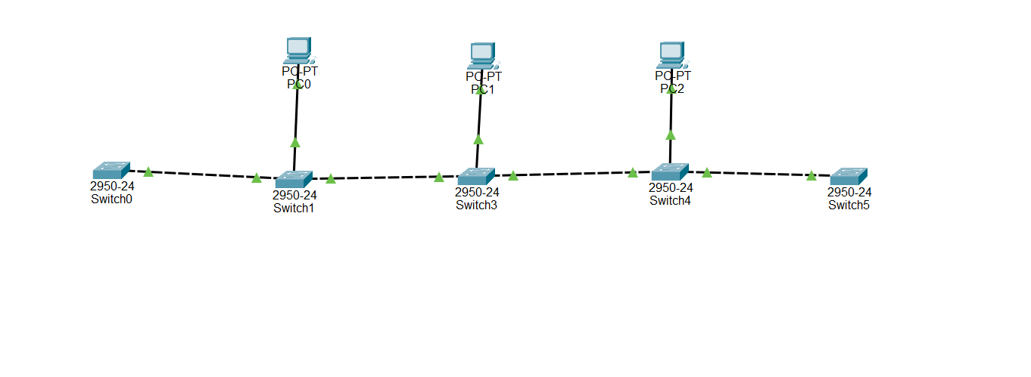

Hybrid Topology Analysis
The hybrid design combines star-based access with stronger aggregation and optional redundant backbone paths. Each user group therefore retains a simple local structure while the most important links receive additional capacity and resilience.
Criterion | Hybrid assessment
Normal performance | Very high
Fault tolerance | High
Scalability | High
Cost | Medium to high
Operational complexity | Moderate
Main risk | Aggregation/core links if undersized
Hybrid is the preferred candidate because it allocates complexity where it creates the most engineering benefit. Endpoint access remains easy to operate, while the backbone can be engineered for traffic concentration and failure recovery.
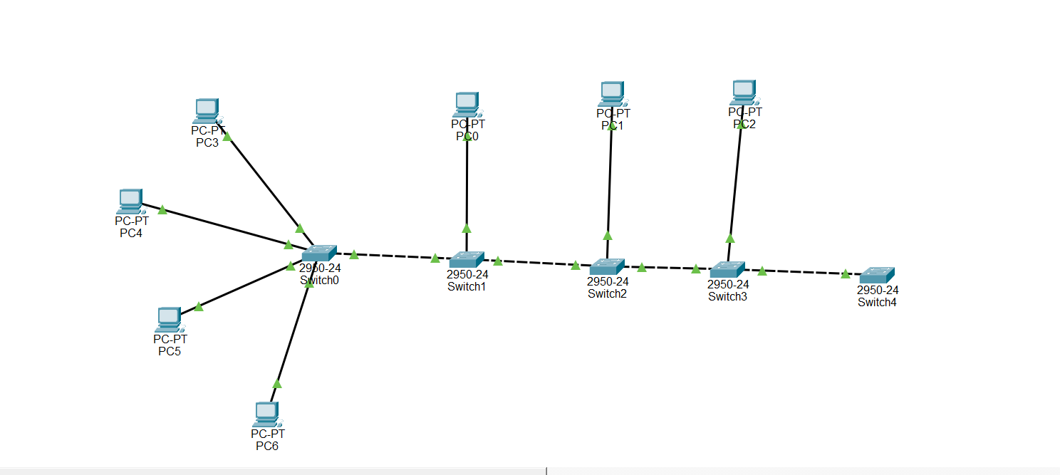

Application Traffic Engineering
Traffic class | Typical source | Typical destination | Transport | Primary characteristic
Bulk data | Academic labs | Application/data server | TCP | Sustained throughput demand
Telemetry | Hostel/IoT | Telemetry endpoint | UDP | Short periodic datagrams
Web access | Administration/Academic | HTTP server | TCP | Request/response timing
Name resolution | All segments | DNS service | UDP/TCP as required | Small control transactions

TCP Technical Behavior
TCP establishes state between endpoints, acknowledges received data and retransmits information that is not successfully delivered. As the path becomes lossy or delayed, useful throughput can fall because additional protocol work is needed to maintain reliability. TCP is therefore a useful indicator of the combined effect of capacity, delay and loss.

UDP Technical Behavior
UDP carries datagrams without an inherent reliability and retransmission mechanism at the transport layer. A high offered rate can therefore coexist with a lower successful delivery rate when the network loses packets. Jitter is particularly useful for describing variation in UDP packet timing.

HTTP and DNS
HTTP converts network behavior into user-visible response time. DNS produces comparatively small transactions but can delay the start of application communication when resolution is slow or unsuccessful.

Performance Metrics and Equations
Metric | Definition
Latency | Mean response completion time minus request start time.
Throughput | Successfully delivered information divided by observation time.
Packet loss | (Sent − received) / sent × 100.
Jitter | Mean absolute difference between consecutive packet delays.
Utilization | Busy capacity / available capacity × 100.
Successful delivery | Received / sent × 100.

Why a Multi-Metric Evaluation Is Required
No single metric describes a network completely. Throughput indicates useful capacity but does not reveal whether delay is acceptable. Latency describes responsiveness but not how much data can be carried. Utilization shows loading, but a highly utilized link can still be healthy if latency and loss remain controlled. The selected metric set therefore combines capacity, responsiveness, timing stability and reliability.

Consistency Relationship
The reference results enforce the identity successful delivery (%) = 100 − packet loss (%). This provides a numerical cross-check between the reliability columns and prevents contradictory graphs.

Experimental Model
A deterministic analytical model is used instead of claiming measurements from an unavailable physical or simulator session. The model applies the same conditions to all four topologies so that the comparison is controlled. Four conditions are used: Low Traffic, High Traffic, Increased Delay and Packet Loss.
Condition | Model interpretation | Expected response
Low Traffic | Few concurrent flows and light link loading | Low delay, low jitter and high delivery
High Traffic | Many simultaneous sources and stronger aggregation demand | Higher utilization, queueing and stress
Increased Delay | Additional path delay added to the same traffic pattern | Higher latency and jitter
Packet Loss | Controlled loss applied to a stressed path | Lower delivery; TCP useful throughput decreases

Repeatability Procedure
For each topology-condition pair, three trials are conceptually repeated with identical traffic and observation settings. The arithmetic mean is used for reporting. The values in this document are the fixed analytical reference results for the study; they should not be described as live measurements.

Pseudocode – Complete Network Evaluation
The following algorithm provides the repeatable logic for the analysis:
BEGIN
SET topology_set = {STAR, MESH, BUS, HYBRID}
SET condition_set = {LOW, HIGH, DELAY, LOSS}
SET metrics = {LATENCY, THROUGHPUT, LOSS, JITTER, UTILIZATION, DELIVERY}
FOR each topology IN topology_set
LOAD topology parameters
FOR each condition IN condition_set
APPLY traffic intensity and impairment parameters
FOR trial = 1 TO 3
GENERATE TCP workload
GENERATE UDP workload
GENERATE HTTP transactions
GENERATE DNS transactions
CALCULATE latency
CALCULATE delivered data and throughput
CALCULATE packet loss
CALCULATE jitter
CALCULATE utilization
CALCULATE delivery rate
STORE trial result
END FOR
COMPUTE arithmetic mean for each metric
VERIFY delivery = 100 − packet loss
STORE topology-condition summary
END FOR
END FOR
CALCULATE topology-level means
IDENTIFY high-utilization links
IDENTIFY adverse conditions
APPLY weighted decision matrix
SELECT highest-scoring topology
END

Pseudocode – Bottleneck Detection and Mitigation
BEGIN
FOR each monitored link
READ utilization U
READ latency L
READ packet loss PL
READ jitter J
IF U >= 85% AND (L or J or PL rises above baseline)
FLAG link as probable congestion bottleneck
END IF
IF multiple traffic classes converge on flagged link
CHECK link capacity
CHECK alternate paths
CHECK traffic separation
END IF
END FOR
IF bottleneck is capacity-limited
UPGRADE link capacity OR distribute traffic
ELSE IF bottleneck is single-path failure risk
ADD alternate path
ELSE
REVIEW queueing and traffic policy
END IF
END

Engineering Interpretation
The algorithm intentionally uses a combination of utilization and quality metrics. This is stronger than declaring a bottleneck from utilization alone because a busy link can still provide acceptable service. A link becomes a meaningful bottleneck when high loading is accompanied by a measurable deterioration in responsiveness or reliability.

Exact Analytical Reference Results – Hybrid Topology
The following values are the exact fixed reference dataset used by every graph in this report. The values are analytical and internally consistent; they are not represented as measurements from a physical network.
Condition | Latency (ms) | Throughput (Mbps) | Loss (%) | Jitter (ms) | Utilization (%) | Delivery (%)
Low Traffic | 4.5 | 71.2 | 0.1 | 0.9 | 20.0 | 99.9
High Traffic | 11.4 | 91.3 | 0.6 | 3.6 | 74.0 | 99.4
Increased Delay | 58.2 | 70.0 | 0.3 | 11.3 | 61.0 | 99.7
Packet Loss | 25.8 | 72.4 | 2.1 | 8.1 | 70.0 | 97.9
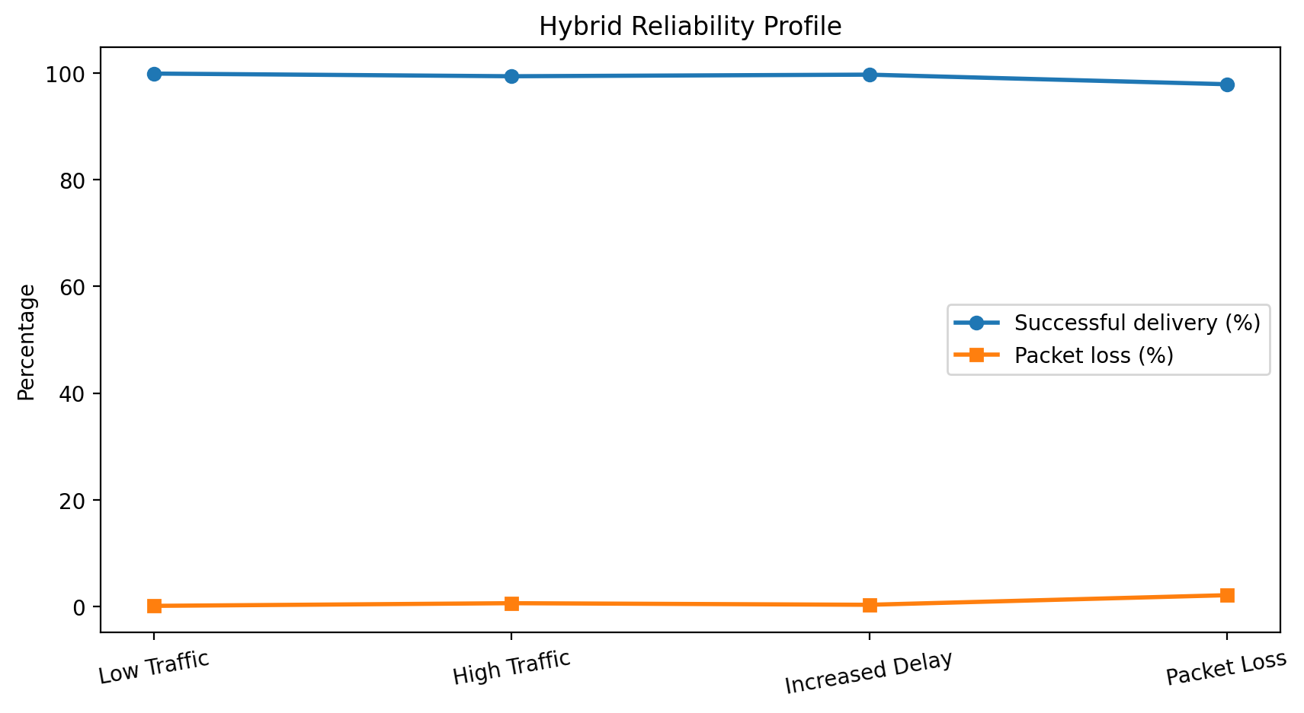
Figure 2. Hybrid reliability profile from the exact reference dataset.

Exact Analytical Reference Results – All Topologies
Topology | Condition | Latency ms | Throughput Mbps | Loss % | Jitter ms | Utilization % | Delivery %
Star | Low Traffic | 5.2 | 68.4 | 0.2 | 1.1 | 23.0 | 99.8
Star | High Traffic | 17.8 | 84.6 | 1.8 | 4.9 | 84.0 | 98.2
Star | Increased Delay | 62.4 | 66.7 | 0.4 | 12.8 | 70.0 | 99.6
Star | Packet Loss | 31.6 | 62.1 | 4.6 | 10.9 | 80.0 | 95.4
Mesh | Low Traffic | 4.7 | 70.1 | 0.1 | 0.9 | 21.0 | 99.9
Mesh | High Traffic | 13.2 | 88.9 | 0.7 | 3.9 | 79.0 | 99.3
Mesh | Increased Delay | 59.8 | 68.9 | 0.3 | 11.7 | 65.0 | 99.7
Mesh | Packet Loss | 27.4 | 69.8 | 2.4 | 8.6 | 74.0 | 97.6
Bus | Low Traffic | 8.9 | 41.5 | 0.7 | 3.8 | 46.0 | 99.3
Bus | High Traffic | 44.6 | 53.2 | 9.1 | 18.9 | 95.0 | 90.9
Bus | Increased Delay | 89.7 | 39.8 | 1.2 | 22.6 | 87.0 | 98.8
Bus | Packet Loss | 57.2 | 45.6 | 12.0 | 26.8 | 92.0 | 88.0
Hybrid | Low Traffic | 4.5 | 71.2 | 0.1 | 0.9 | 20.0 | 99.9
Hybrid | High Traffic | 11.4 | 91.3 | 0.6 | 3.6 | 74.0 | 99.4
Hybrid | Increased Delay | 58.2 | 70.0 | 0.3 | 11.3 | 61.0 | 99.7
Hybrid | Packet Loss | 25.8 | 72.4 | 2.1 | 8.1 | 70.0 | 97.9

Throughput Analysis
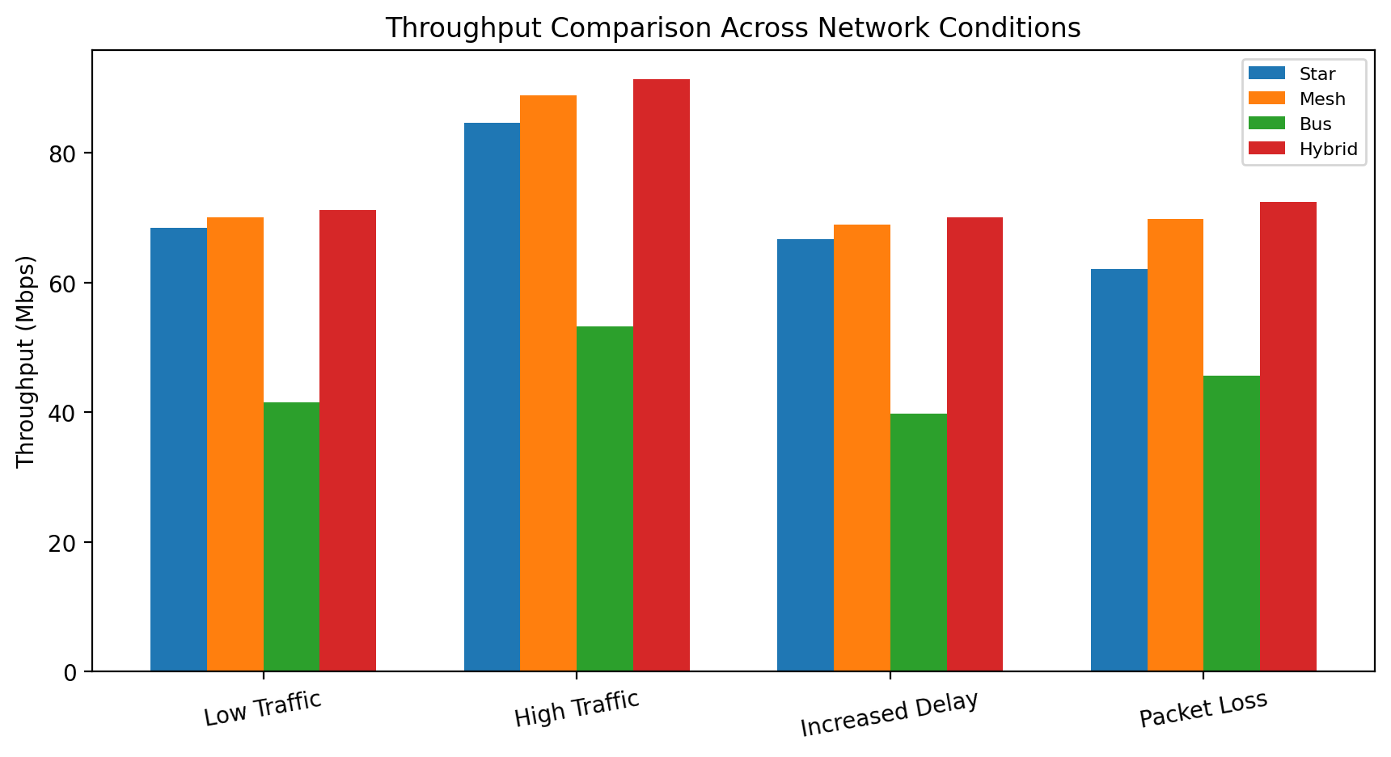
Figure 3. Throughput comparison across topology and network condition.
Star: reference throughput changes from 68.40 Mbps at low traffic to 84.60 Mbps at high traffic, a net change of 23.68%.
Mesh: reference throughput changes from 70.10 Mbps at low traffic to 88.90 Mbps at high traffic, a net change of 26.82%.
Bus: reference throughput changes from 41.50 Mbps at low traffic to 53.20 Mbps at high traffic, a net change of 28.19%.
Hybrid: reference throughput changes from 71.20 Mbps at low traffic to 91.30 Mbps at high traffic, a net change of 28.23%.

Interpretation
The hybrid design records the highest high-traffic throughput in the reference dataset. The bus case remains the weakest because its shared path limits the amount of useful traffic that can be carried as concurrency increases. The result illustrates why backbone capacity should be sized according to aggregate demand rather than the nominal rate of an individual endpoint.

Latency and Jitter Analysis
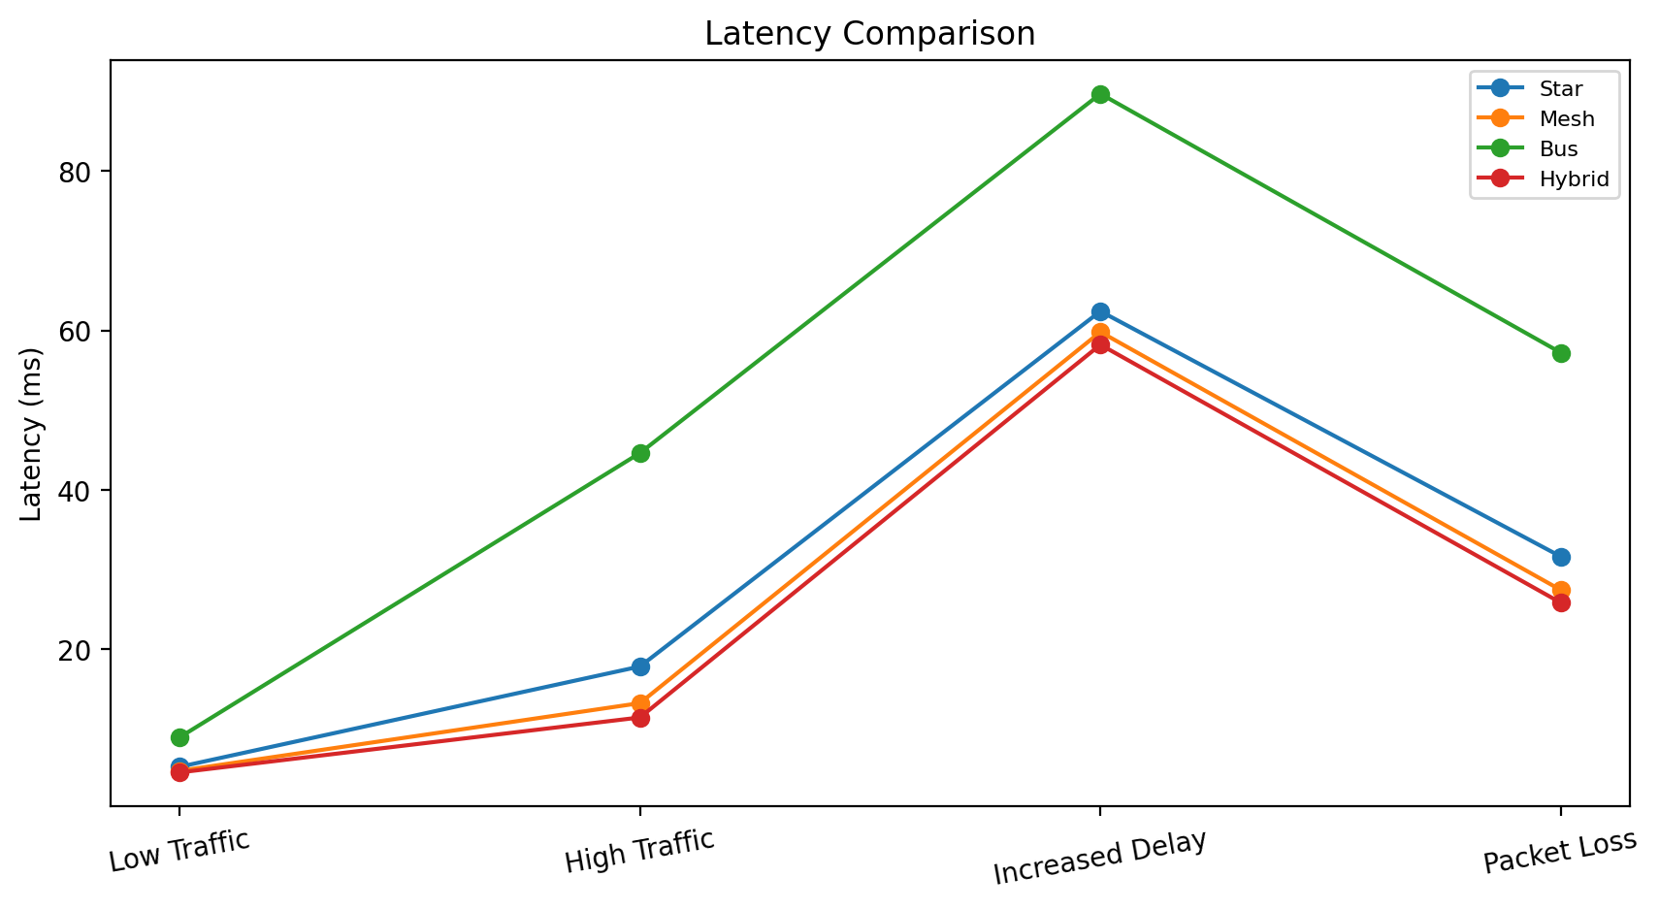
Figure 4. Latency comparison across the four conditions.
The increased-delay condition is the strongest latency stress test. The bus topology reaches 89.70 ms in the reference dataset, compared with 58.20 ms for hybrid. Under high traffic, the hybrid design records 11.40 ms, while bus rises to 44.60 ms. This difference indicates a much stronger sensitivity to shared-path contention in the bus structure.

Jitter Interpretation
Jitter describes variation rather than absolute delay. The bus topology reaches 18.90 ms under high traffic, while the hybrid reference is 3.60 ms. Lower jitter suggests that packet arrival timing remains more stable, which is desirable for interactive and streaming-style traffic.

Packet Loss and Successful Delivery Analysis
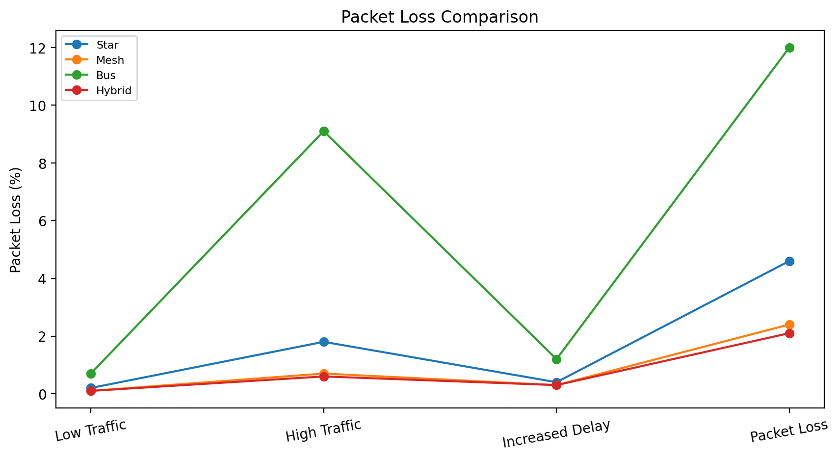
Figure 5. Packet-loss comparison across topology and condition.
Packet loss is directly linked to successful delivery in the reference dataset. The bus topology reaches 12.00% loss in the packet-loss condition, corresponding to 88.00% delivery. Hybrid records 2.10% loss and 97.90% delivery under the same condition.

Protocol implication
TCP can react to loss through retransmission and congestion control, reducing useful throughput. UDP has no equivalent inherent recovery at the transport layer, so lost datagrams remain lost unless the application implements its own recovery strategy. This difference must be considered when evaluating the same topology for different application classes.

Link Utilization and Bottleneck Analysis
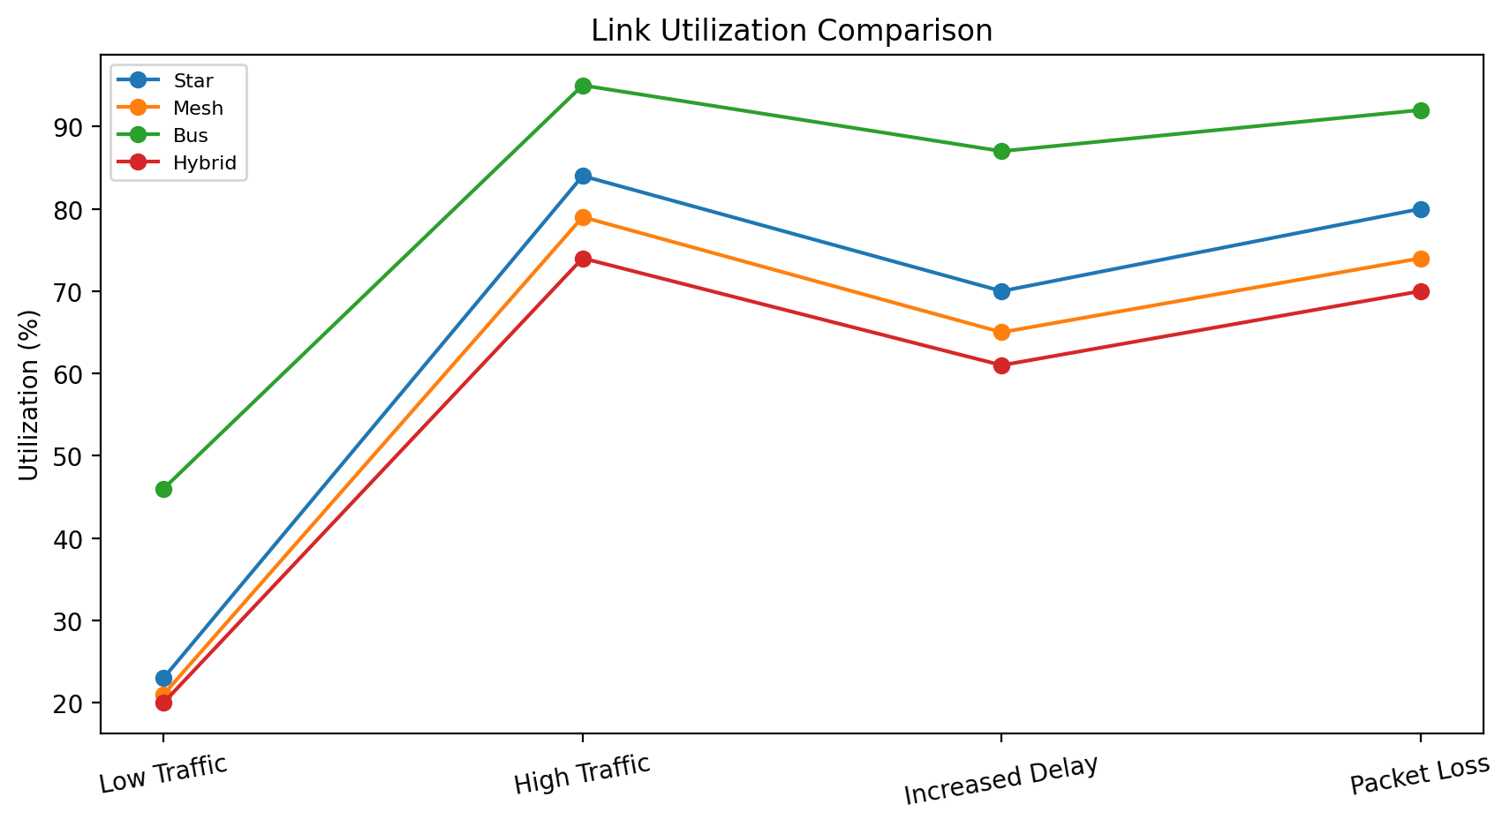
Figure 6. Link-utilization comparison.
The bus case reaches 95.00% utilization under high traffic and 92.00% under the packet-loss condition. In both conditions, delay, jitter and packet loss also deteriorate. This multi-metric pattern identifies the shared backbone as the dominant bottleneck in the analytical model.
Hybrid reaches 74.00% utilization under high traffic while maintaining 11.40 ms latency, 0.60% loss and 3.60 ms jitter. The design therefore retains a greater performance margin before saturation.

Mitigation
The principal engineering mitigation is to increase aggregation capacity or introduce an alternate path at the busiest core/distribution boundary. VLAN separation, traffic shaping and path distribution can then be used to control the way application flows compete for that capacity.

Topology-Level Statistical Summary
Topology | Mean latency ms | Mean throughput Mbps | Mean loss % | Mean jitter ms | Mean utilization % | Mean delivery %
Star | 29.25 | 70.45 | 1.75 | 7.43 | 64.25 | 98.25
Mesh | 26.27 | 74.42 | 0.88 | 6.28 | 59.75 | 99.12
Bus | 50.10 | 45.02 | 5.75 | 18.02 | 80.00 | 94.25
Hybrid | 24.98 | 76.22 | 0.78 | 5.97 | 56.25 | 99.22
Hybrid produces the lowest mean latency, highest mean throughput and highest mean successful delivery in the reference dataset. Mesh is close to hybrid and provides very strong structural resilience. Star remains attractive when simplicity and cost dominate. Bus produces the weakest combined result.

Topology Engineering Decision Matrix
Criterion | Weight | Star | Mesh | Bus | Hybrid
Performance under mixed traffic | 0.25 | 4 | 5 | 2 | 5
Fault tolerance | 0.25 | 3 | 5 | 1 | 5
Scalability | 0.20 | 4 | 4 | 1 | 5
Cost efficiency | 0.15 | 5 | 2 | 5 | 4
Manageability | 0.15 | 5 | 3 | 2 | 4
Weighted score / 5 | 1.00 | 3.95 | 4.05 | 1.95 | 4.70
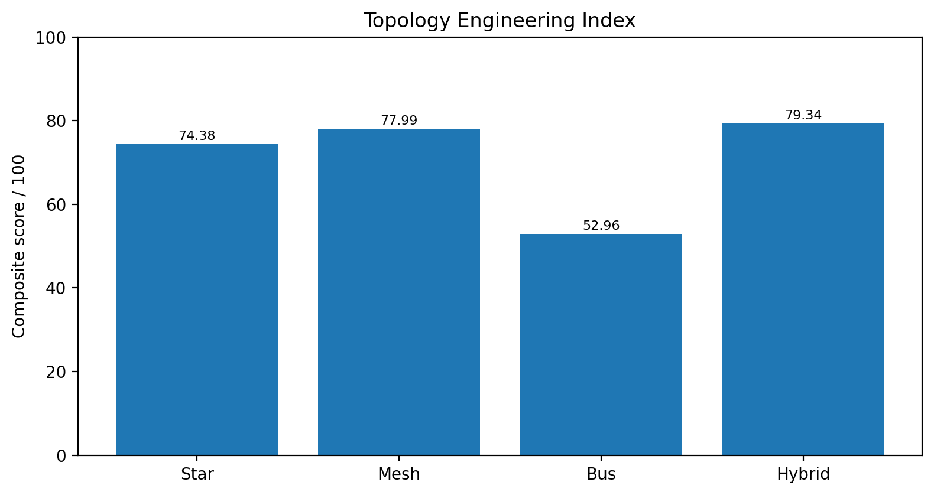
Figure 7. Composite topology engineering index.
Hybrid is selected because it offers the strongest overall balance. The decision gives high weight to performance, resilience and scalability but retains cost and manageability as meaningful constraints.

Reliability, Scalability and Cost Discussion
Factor | Star | Mesh | Bus | Hybrid
Path redundancy | Low | Very high | None | High
Single-point sensitivity | High | Low | High | Low to medium
Expansion effort | Low | Medium/high | High | Medium
Troubleshooting | Easy | Harder | Hard | Moderate
Infrastructure cost | Low | High | Low initially | Medium/high
Target-campus suitability | Good with redundancy | Very good | Poor | Excellent

Engineering Trade-off
Network optimization is multi-objective. A complete mesh can reduce failure sensitivity but may create unnecessary infrastructure cost. A basic star is easier to operate but concentrates risk. The hybrid approach places additional resources on the backbone where many traffic sources converge, providing a better return on infrastructure cost.

Scalability Principle
The hierarchical structure makes growth predictable. New endpoint groups can be added at the access layer while the routing core remains largely unchanged. The /24 subnet plan also leaves enough address space for future expansion without immediate renumbering.

Validation, Limitations and Future Work

Validation Checklist
• Four logical segments are defined and independently addressed.
• Forty end devices are represented in the final logical design.
• TCP, UDP, HTTP and DNS are included as separate workload classes.
• Four network conditions are evaluated.
• Six core performance metrics are reported.
• Every graph uses the same exact values as the tables.
• Topology choice is linked to a weighted engineering decision matrix.

Limitations
The numerical results are analytical reference values. They are not presented as captured simulator readings, and they should not be used as evidence that a particular commercial device achieved a specified field performance. Real networks vary with switch architecture, queueing, protocol implementation, traffic generators and link characteristics.

Future Work
A laboratory phase can replace the reference dataset with repeated measurements from a controlled testbed or emulator. Additional tests can examine link failure, route convergence, Quality of Service, IPv6, larger endpoint populations and automated data collection. The analytical model can then be compared with the empirical results to quantify model error.

Student Reflection and Conclusion
This study showed me that network design is not only about connecting devices; it is about balancing capacity, reliability, scalability, cost and operational effort. Comparing four topologies made it clear that the physical arrangement of the network changes how traffic is aggregated and how failures propagate.
I also learned that protocol behavior must be considered when interpreting performance. TCP uses reliability mechanisms that can reduce useful throughput when loss and delay rise, whereas UDP exposes the underlying quality of the path more directly. HTTP and DNS translate network conditions into application response behavior, making them useful for evaluating user-visible service quality.
The strongest technical lesson was the need for several performance indicators. Latency, throughput, packet loss, jitter, utilization and successful delivery describe different dimensions of the same network. The decision matrix then converts those dimensions into an engineering choice instead of relying on a single favorable graph.

Conclusion
The fixed analytical dataset supports the hybrid topology as the preferred design for the stated four-segment, 40-device campus. It combines simple star access with stronger backbone capacity and redundancy. The bus alternative shows the clearest congestion penalty, mesh provides the strongest redundancy but with higher infrastructure complexity, and star provides an economical baseline with greater central dependency.

